Group 14 - Assignment 4

Sarah McLaughlin

Mahmoud Thabit

Byron Doyal

# Table of Contents

**Table of Contents** **1**

**Use Case Diagrams** **2**

Use Case Diagram - Grading an assignment/project submission (Sarah McLaughlin) 2

Use Case Diagram - Setting up a course (Sarah McLaughlin) 3

Use Case Diagram - Submitting a project (Mahmoud Thabit) 4

Use Case Diagram - Creating an assignment (Mahmoud Thabit) 5

**Activities Diagrams** **6**

Activity Diagram - Grading a project/assignment (Sarah McLaughlin) 6

Activity Diagram - Submitting a project/assignment (Mahmoud Thabit) 7

Activity Diagram - Adding and removing a TA from a course (Byron Doyal) 8

**Class Diagram - Adding and removing students for instructor (Byron Doyal)** **9**

**Entity-Relationship Diagram (Mahmoud Thabit)** **10**

**Sequence Diagram - Student is able to read assignment instructions (Byron Doyal)** **11**

**State Machine Diagram - Course enrollment process (Sarah McLaughlin)** **12**

# Use Case Diagrams

## Use Case Diagram - Grading an assignment/project submission (Sarah McLaughlin)

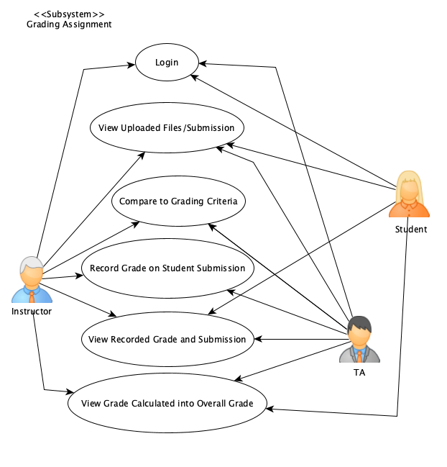

Assignment Grading Use Case Diagram:

Primary Actors: TA/Instructor and Student

Description: This shows the process of the TA or Instructor that reviews the assignment submission or files, then comparing that specific student’s submission with the grading criteria. Once a file decision has been made, either the TA or Instructor can submit the final grade of the student. That grade is then calculated into the student’s total grade.

## Use Case Diagram - Setting up a course (Sarah McLaughlin)

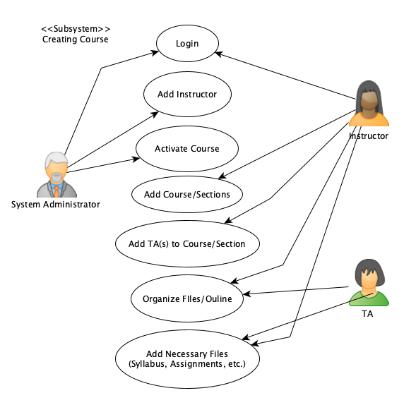

Creating Course Use Case Diagram:

Primary Actors: System Administrator and TA/Instructor

Description: This diagram shows the process of creating a course. The system administrator adds the instructor and activates the course which then gives the instructor access to add whatever is necessary for the course, including giving the TA access to the course or sections. Both the TA and instructor then organize and outline the course and add files to the course or each section.

## Use Case Diagram - Submitting a project (Mahmoud Thabit)

## 

Submitting a Project Use Case Diagram:

Primary Actors: Student, TA, and Instructor

Description: This diagram shows the process of submitting a project. The student login to a website then chooses the project that he wants to submit. the student then uploads project files, then he/she has the option to preview the files uploaded to make sure the files are correct. if everything is good then the student commits the file uploaded by submitting the project. the student also has the option to go back and view uploaded files. TA and the Instructor can log in to view uploaded files

## Use Case Diagram - Creating an assignment (Mahmoud Thabit)

# 

Creating an Assignment Use Case Diagram:

Primary Actors: TA, and Instructor

Description: This diagram shows the process of creating an assignment. In this case, the TA and/or Instructor are the main users. to create an assignment first the Instructor or/and the TA have to log in. the assignment is required to be named, then the relevant documents have to be uploaded (rubric, assignment description, ... etc.) the assignment has to have a due date and a grade must be set to. then the assignment can be published for the students to see and work on it.

# Activities Diagrams

## Activity Diagram - Grading a project/assignment (Sarah McLaughlin)

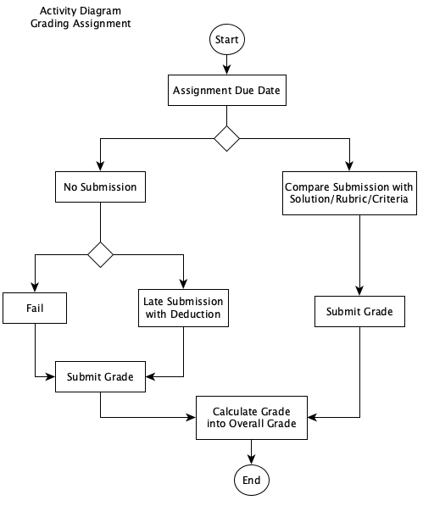

Description: This Activity Diagram follows the steps after the submission. If the assignment was submitted, then the submission is compared the solution and the grade is submitted. If the assignment was not submitted by the due date, then the student receives a fail or a late submission. After that, the grade is submitted, and the grade for the assignment goes into the overall calculation of the student’s grade.

## Activity Diagram - Submitting a project/assignment (Mahmoud Thabit)

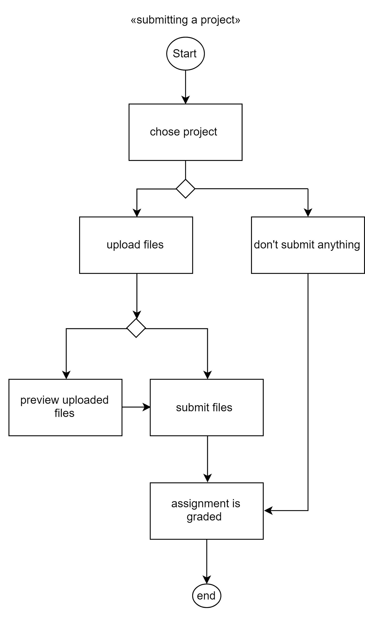

## 

## Activity Diagram - Adding and removing a TA from a course (Byron Doyal)

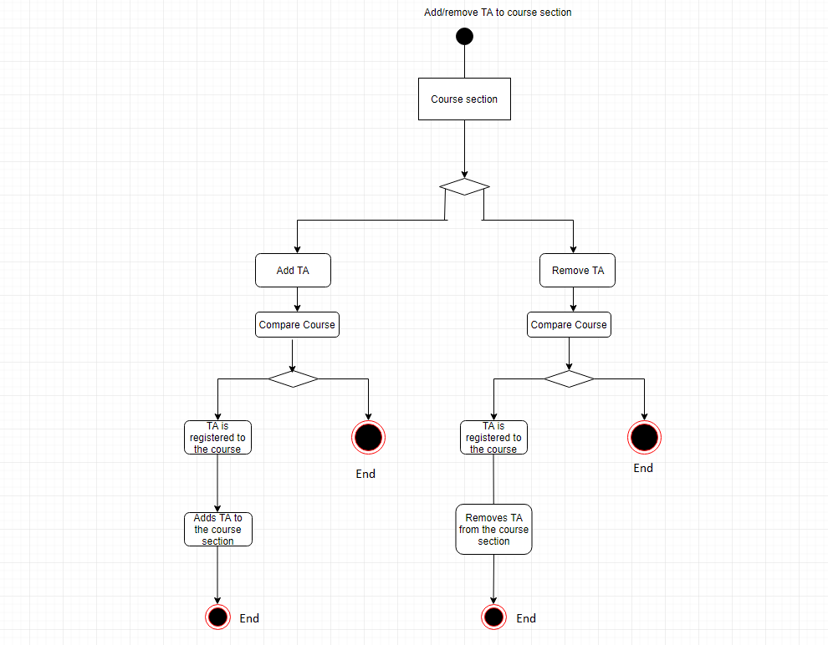

# Class Diagram - Adding and removing students for instructor (Byron Doyal)

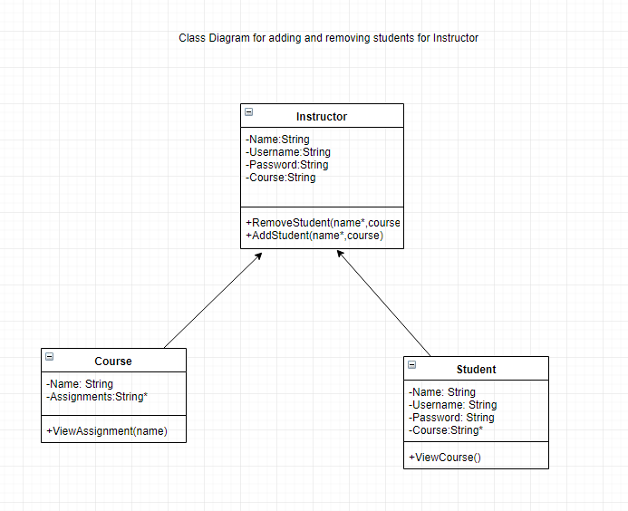

# Entity-Relationship Diagram (Mahmoud Thabit)

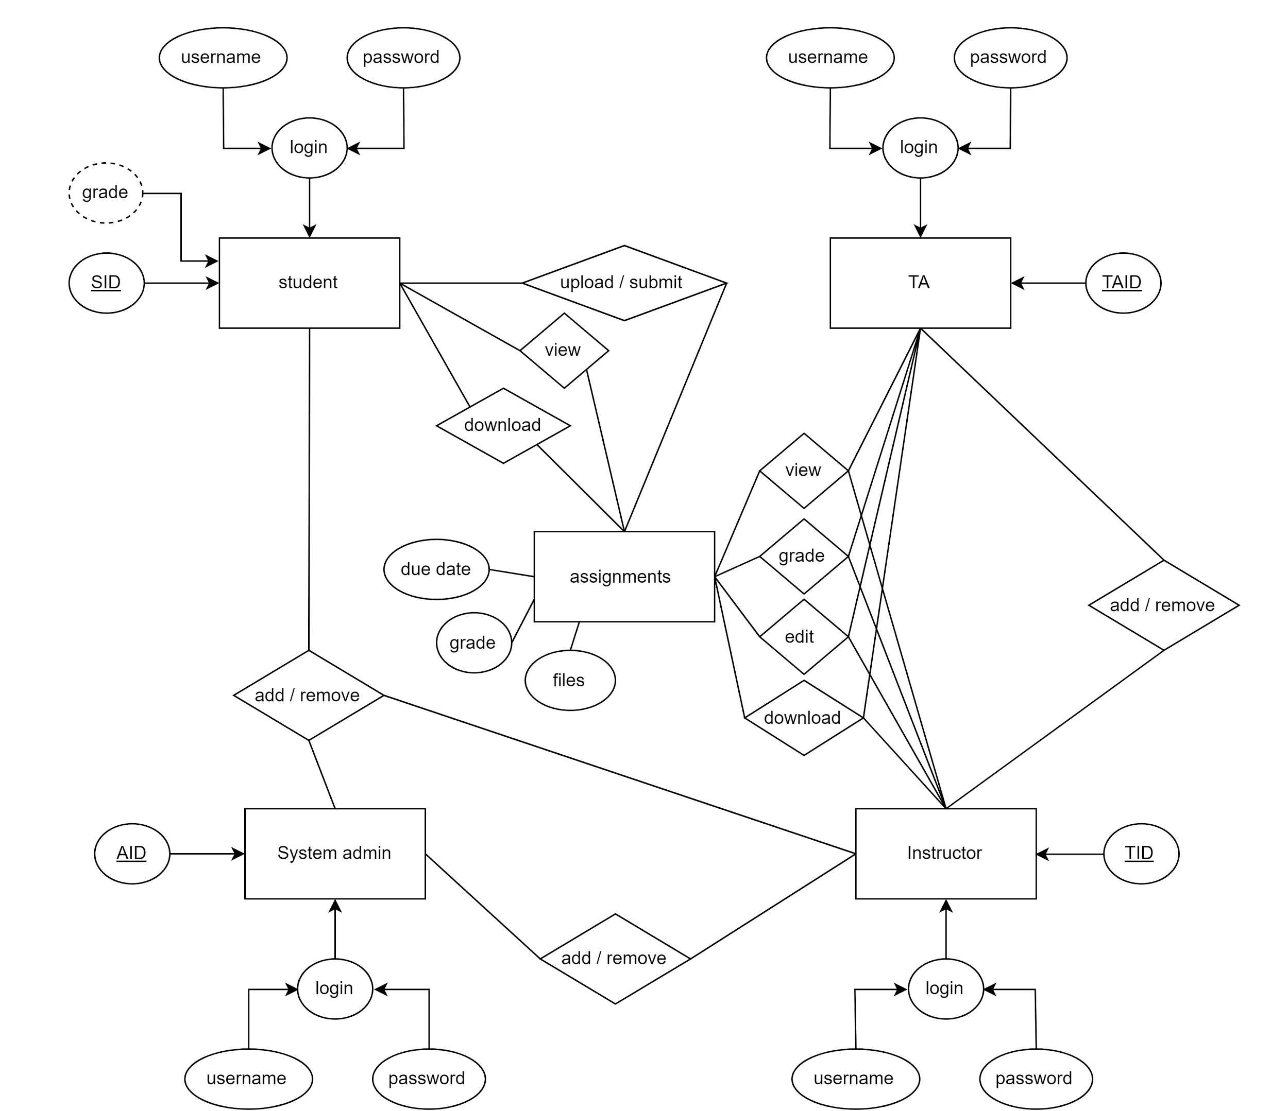

Description: This diagram shows the entities and how they are related to each having their own attributes. a student has SID as a key and login information with the grade being derived from assignments. student can be added and removed by the instructor or system admin. student can upload/ submit, view, and download documents from assignments. TAs have login information with a TAID as a key, TAs can be added and removed by the instructor, they also have the same capabilities as the instructor when it comes to viewing, grading, editing, and downloading assignment. The instructor has login information and TID as a key. the instructor can be added and removed by System admin. The instructor can view, grade, edit, and download assignments. System admin has an AID as a key and login information. can add and remove instructors and students. The assignment has a due date, grade, and files, which can be accessed by students, TA, and instructors.

# Sequence Diagram - Student is able to read assignment instructions (Byron Doyal)

# 

# 

# 

# State Machine Diagram - Course enrollment process (Sarah McLaughlin)

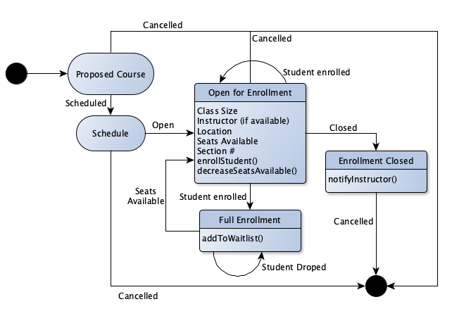

Description: This State Machine Diagram shows the enrollment process a student undergoes when enrolling for a specific course. The course is first proposed, where it is then scheduled (if not cancelled). From there, there student is able to enroll if there is still room in the class. If there is no room, the student has to be put on the waitlist until a student drops or more seats are available. This diagram continues until enrollment closes, and if a student was not able to enroll by that point they must notify the instructor.